Write a Custom OAuth 2.0 Grant Type

Introduction

OAuth 2.0 authorization servers provide support for four main grant types according to the OAuth 2.0 specification. It also has the flexibility to support any custom grant types. To implement a custom grant type, you need to write a handler and a validator for your grant type.

Grant Type Handler
Specifies how the validation must be done and how the token should be issued. This can be done in two ways. Either you can implement the “AuthorizationGrantHandler” interface or you can extend the “AbstractAuthorizationGrantHandler” class.

Grant Type Validator
Verifies and validates the token request and checks whether all the required parameters are sent with the request. This can be implemented by extending the “AbstarctValidator” class.

Scenario
In this exercise, we are implementing a simple custom grant type called “Mobile Grant”. You will pass a mobile number to the OAuth2 “token” endpoint in exchange for an access token.

Write the Custom Grant Handler

Follow the steps given below.
- Create a maven project and in the source folder (a folder named Java), create a package (org.wso2.carbon.identity.custom.grant) for the new grant type. Then create two java classes for the validator and the handler.
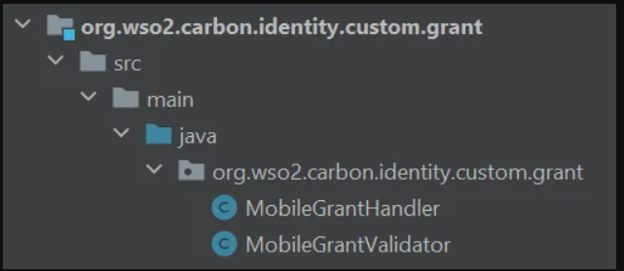
- In the handler class extend the AbstractAuthorizationGrantHandler class.
Then override the validateGrant method and implement the custom logic as follows:

public class MobileGrant extends AbstractAuthorizationGrantHandler {

private static Log log = LogFactory.getLog(MobileGrant.class);
public static final String MOBILE_GRANT_PARAM = "mobileNumber";

@Override
public boolean validateGrant(OAuthTokenReqMessageContext
oAuthTokenReqMessageContext) throws IdentityOAuth2Exception {

log.info("Mobile Grant handler is hit");

boolean authStatus = false;

// extract request parameters
RequestParameter[] parameters = oAuthTokenReqMessageContext
.getOauth2AccessTokenReqDTO().getRequestParameters();

String mobileNumber = null;

// find out mobile number
for (RequestParameter parameter : parameters) {
if (MOBILE_GRANT_PARAM.equals(parameter.getKey())) {
if (parameter.getValue() != null && parameter.getValue().length > 0) {
mobileNumber = parameter.getValue()[0];
}
}
}

if (mobileNumber != null) {
//validate mobile number
authStatus = isValidMobileNumber(mobileNumber);

if (authStatus) {
// if valid set authorized mobile number as grant user
String tenantAwareUsername = MultitenantUtils
.getTenantAwareUsername(mobileNumber);
/*
Please use AuthenticatedUser
.createFederateAuthenticatedUserFromSubjectIdentifier()
if a federated user is involved with this custom grant.
*/
AuthenticatedUser mobileUser = AuthenticatedUser
.createLocalAuthenticatedUserFromSubjectIdentifier(
tenantAwareUsername);
// Set the federated IdP name if a federated user is involved
// with this custom grant.
// mobileUser.setFederatedIdPName(FrameworkConstants.LOCAL_IDP_NAME);

oAuthTokenReqMessageContext.setAuthorizedUser(mobileUser);
oAuthTokenReqMessageContext.setScope(
oAuthTokenReqMessageContext.getOauth2AccessTokenReqDTO()
.getScope());
} else {
ResponseHeader responseHeader = new ResponseHeader();
responseHeader.setKey("SampleHeader-999");
responseHeader.setValue("Provided Mobile Number is Invalid.");
oAuthTokenReqMessageContext.addProperty("RESPONSE_HEADERS",
new ResponseHeader[]{responseHeader});
}

}

return authStatus;
}

@Override
public OAuth2AccessTokenRespDTO issue(OAuthTokenReqMessageContext tokReqMsgCtx) throws IdentityOAuth2Exception {

OAuth2AccessTokenRespDTO tokenRespDTO = new OAuth2AccessTokenRespDTO();
tokenRespDTO.setExpiresIn(tokReqMsgCtx.getAccessTokenIssuedTime() + 10000);
tokenRespDTO.setAccessToken(UUID.randomUUID().toString());
tokenRespDTO.setRefreshToken(UUID.randomUUID().toString());
tokenRespDTO.setTokenType("mobile");
return tokenRespDTO;
}

public boolean authorizeAccessDelegation(OAuthTokenReqMessageContext tokReqMsgCtx)
throws IdentityOAuth2Exception {

// if we need to just ignore the end user's extended verification
return true;
}

public boolean validateScope(OAuthTokenReqMessageContext tokReqMsgCtx)
throws IdentityOAuth2Exception {

// if we need to just ignore the scope verification
return true;
}

/**
* You need to implement how to validate the mobile number
*
* @param mobileNumber Mobile number of the user.
* @return true if the mobile number is valid, otherwise false.
*/
private boolean isValidMobileNumber(String mobileNumber) {

// Regular expression to match 10 digits, with optional country code
String pattern = "^(\\+\\d{1,3})?\\d{10}$";
// Create a Pattern object
Pattern r = Pattern.compile(pattern);
// Create Matcher object
Matcher m = r.matcher(mobileNumber);
// Check if the pattern matches
return m.matches();
}

@Override
public boolean isOfTypeApplicationUser() throws IdentityOAuth2Exception {

return true;
}

}

- In the validator class extend the AbstarctValidator class.
In the constructor, mention the mandatory parameters that should be in the request body.
public class MobileGrantValidator extends AbstractValidator {

public MobileGrantValidator() {
requiredParams.add(MobileGrantHandler.MOBILE_NUMBER);
}
}

Prerequisites
- A WSO2 Identity Server setup.
- Please verify that all the system requirements are satisfied.
- An Application registered in Identity Server.
- An application deployed in Tomcat server.
Ex: pickup-dispatch application

Set up

You can use the sample custom grant handler implementation from here.
- Navigate to the <SAMPLE_IS>/oauth2/custom-grant directory and run the following command:
mvn clean install

- Copy the generated jar file in the target folder into <IS_HOME>/repository/components/lib/ folder.
- To register the custom grant type, configure the <IS_HOME>/repository/conf/deployment.toml file by adding a new entry, as shown below.
[[oauth.custom_grant_type]]
name="mobile"
grant_handler="org.wso2.sample.identity.oauth2.grant.mobile.MobileGrant"
grant_validator="org.wso2.sample.identity.oauth2.grant.mobile.MobileGrantValidator"
[oauth.custom_grant_type.properties]
IdTokenAllowed=true
PublicClientAllowed=true
- Restart the server.
- View your created application tab and goto the Protocol tab.
- Select the custom grant type mobile from the Allowed Grant Types list and click Update.
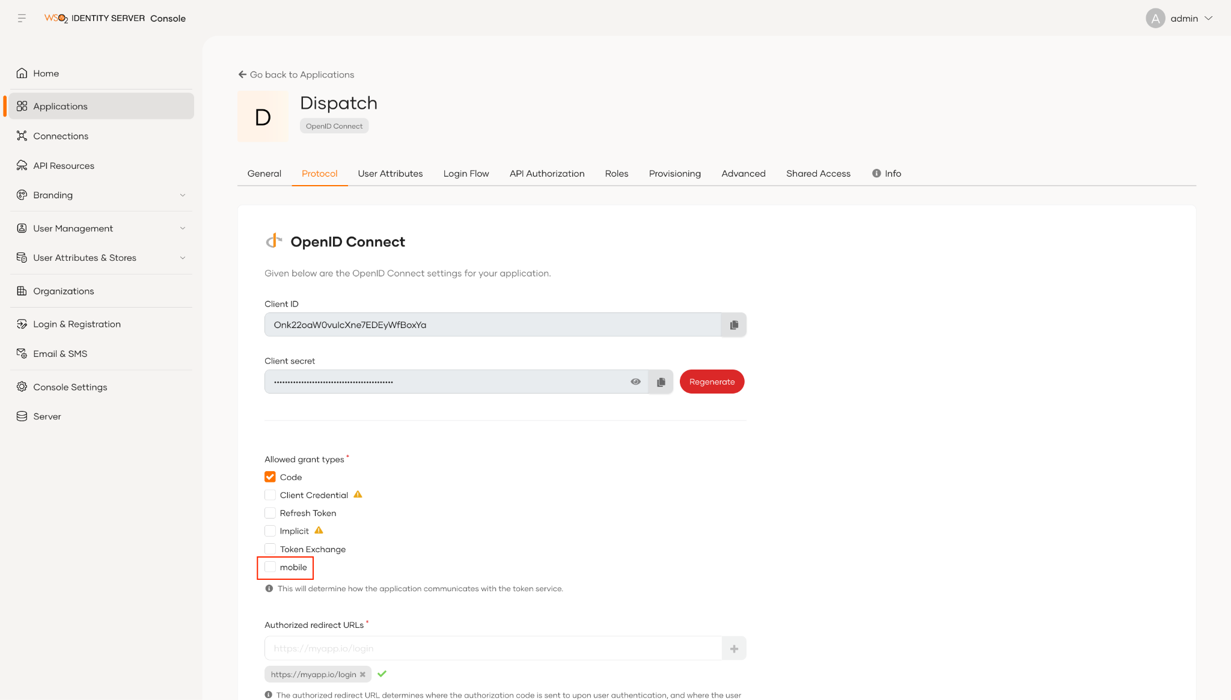
- Create a user and add a valid value for the Mobile field.

Try it out

Follow the steps given below.

- Use the following request for mobile grant token generation.
curl --user <CLIENT_KEY>:<CLIENT_SECRET> -k -d "grant_type=mobile&mobileNumber=<MOBILE_NUMBER>" -H "Content-Type: application/x-www-form-urlencoded" https://localhost:9443/oauth2/token

- You should get a response as below.
